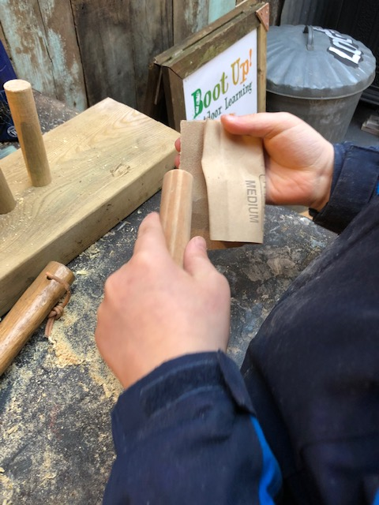

Boot Up Outdoor

Learning

Systems of Control

Assessment

DATE September 2020

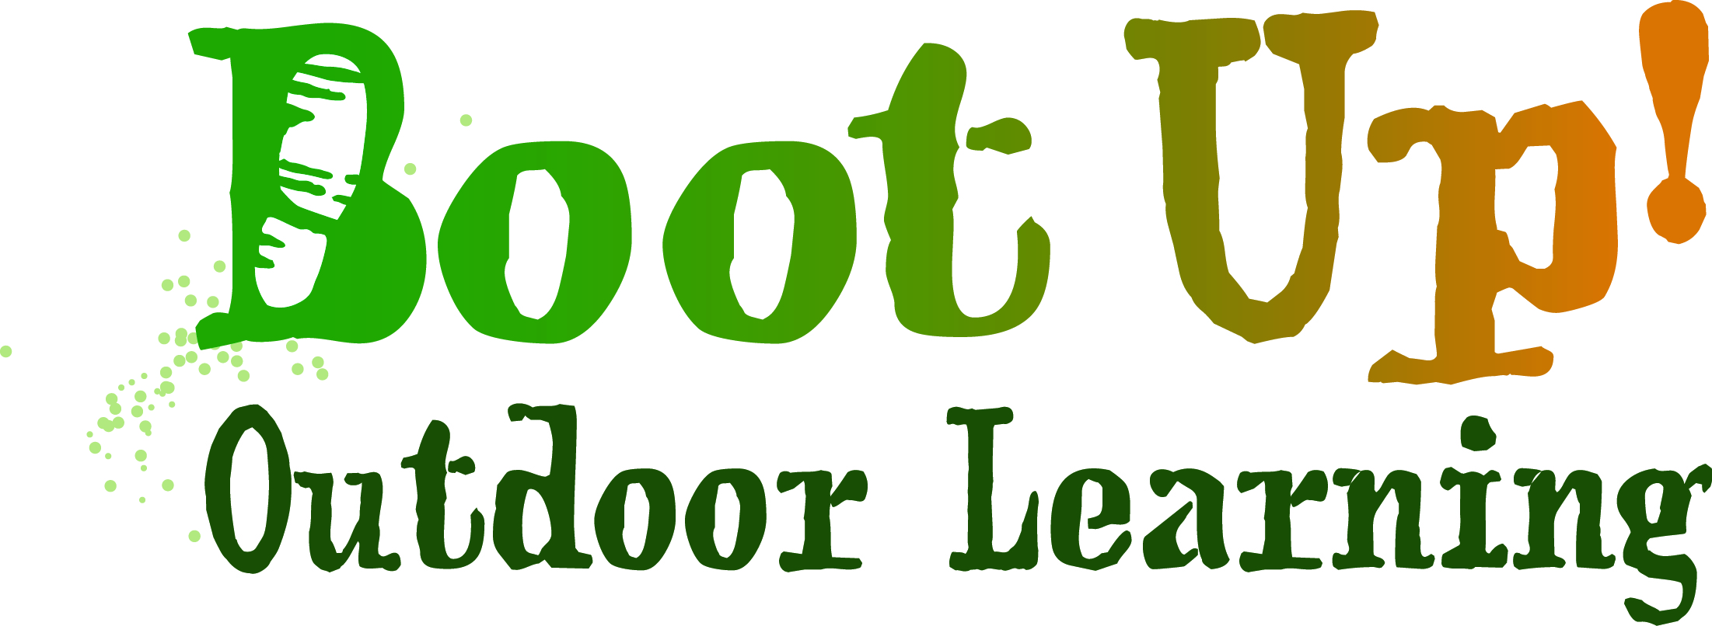

Introduction
Following the introduction of the ‘Guidance for full Opening: Schools - COVID-19 from the Government, Boot Up Outdoor Learning CIC have taken this opportunity to ensure our reopening phased plans adhere to the guidance. The guidance can be accessed through this link:

https://www.gov.uk/government/publications/actions-for-schools-during-the-coronavirus-outbreak/guidance-for-full-opening-schools#section-2-school-operations

This assessment document methodically assesses our plans in response to Government guidance. If the Government guidance cannot be implemented fully, a thorough explanation will be given and details of any other control measures will be provided. Each Government objective is examined and our response is given.

This plan relates to the reopening of Boot Up Outdoor Learning to schools and other related agencies with restricted activities. Visitors and other agencies not related to schools will be asked not to engage until further restrictions are lifted. Further risk assessments will be produced relating to these activities at a later date when it is decided that they will be safe to operate.

Thinking about risk

Objective: that all employers and schools and outside agencies that engage with Boot Up Outdoor Learning should carry out a COVID-19 risk assessment.

Managing risk
Objective: to reduce risk to the lowest reasonably practicable level by taking preventative measures, in order of priority.
As a responsible business, we took the decision to close Boot Up Outdoor Learning to the public and facilitate our team to work from home where possible.
The site was closed to visitors on March 16th 2020 to prevent any spread of COvid-19 to pupils, visitors and staff.
From 14th September 2020 we hope to return to being partially operational following a thorough process of risk assessment and implementing control measures.
In our next phase, we are preparing to open Boot Up Outdoor Learning to those schools and agencies that we have previously engaged with. We have completed a FULL RISK ASSESSMENT (below) to ensure that our control measure in place are sufficient to minimise the risk to our staff and pupils and the spread of COVID-19, before rolling out gradually to all schools and agencies.
Once we are up and running successfully using the above model we hope to extend the days offered to pupils and return Boot Up Outdoor Learning to full functionality.
A generic risk assessment can be found in Appendix 1.
Risk assessments, guidance and and safe system working practices have already been created for staff returning to work.

Sharing the results of our System of Controls
This document will form part of the risk assessment process and advice available to all staff, based on the advice given by the Government and the level of risk to our self-employed workers.
We intend to publish this document and our risk assessment on our website and provide the information to our self-employed staff. This will be a working document so will be adapted or amended as required, either because new information becomes available or in response to feedback, and also in light of any changes to the level of risk.

Prevention

2.0 Robust hand and respiratory hygene

Government guidance | Our comment
Clean hands more often | Boot Up Outdoor Learning to provide hot water and hand sanitiser at all high-impact areas of the site ie: The Barn, The Den, The Perch, Undercover Area, PolyHQ, Toilets
Hand Sanitisers | Boot Up Outdoor Learning to provide Hand Sanitiser at all locations: The Barn, The Den, The Perch, Undercover Area, PolyHQ, Toilets PLUS at the entrance GATE
Clean hands at Toilets | Boot Up Outdoor Learning to provide a wash station with both running water and soap as well as hand sanitiser.
Supervision | Staff will supervise ALL hand wash and sanitiser activity and will supervise wiping down the toilet seat and door handles after use.

Respiratory hygene
Government guidance | Our comment
Sneezing & coughing  Spitting and saliva | Public Health England (PHE) does NOT recommend the use of face masks in school environments  ‘Catch it, Bin It, Kill it’ slogan will be used widely both verbally and physically  Cough or sneeze into elbow to be encouraged  Boot Up Outdoor Learning to provide tissues and pupils encouraged to throw away in specific bins provided  Some pupils with complex needs will struggle to maintain as good respiratory hygiene as their peers, for example those who spit uncontrollably or use saliva as a sensory stimulant.  Pupils be encouraged to NOT spit at staff or others and to use their elbow or spit into a tissue  Boot Up Outdoor Learning to provide tissues and pupils encouraged to throw away in specific bins provided

Enhanced cleaning
Government guidance | Our comment
Enhanced cleaning schedule | Boot Up Outdoor Learning will put in place a cleaning schedule that ensures cleaning is generally enhanced
More frequent cleaning of rooms and shared areas that are used by different groups | At the start and end of each day there will be a full clean down of all shared surfaces  A Green sign will be provided and used for displaying when the room is clean  A Red sign will be provided and used for displaying when the room is to be cleaned
frequently touched surfaces being cleaned more often than normal | There will be a clean down using anti-bacterial spray between each lesson.
Toilets
 | Toilets will need to be cleaned regularly and pupils must be encouraged to clean their hands thoroughly after using the toilet - different groups being allocated their own toilet blocks could be considered but is not a requirement if the site does not allow for it

Minimise contact
Government guidance | Our comment
Social distancing | All colleagues will maintain a strict 2m distance between each other at all times.
Bubbles | Staff and pupils will be divided into ‘bubbles’ of 2 pairs (4 people) and will rotate through the activities in these ‘bubbles’.
Layout | The Manager will ensure members of the team are always working at least 2m apart to strictly maintain social distancing at all times.  Supervisors will use the floor tape provided to mark out areas to help people keep a 2m distance, this is particularly important at collection and drop off points and at start of lessons.  All staff are to maintain a strict 2m distance between each other at all times. Working spaces will be configured to enable this. Boot Up staff also have the option of wearing face masks.  Items should not be passed from hand to hand, a drop off point should be used to keep a 2m distance, and hands/surfaces sanitised before transacting to minimise contact transmission.

PPE for staff

Government guidance | Our comment
Who must wear PPE | The majority of staff in education settings will not require PPE beyond what they would normally need for their work. PPE is only needed in a very small number of cases, including:  - where an individual child or young person becomes ill with coronavirus (COVID-19) symptoms while at schools, and only then if a distance of 2 metres cannot be maintained  - where a child or young person already has routine intimate care needs that involves the use of PPE, in which case the same PPE should continue to be used
Use of masks and gloves | Boot Up Outdoor Learning will provide disposable masks and gloves for us by staff if and when they feel it is necessary. Situations such as: close working with others, cleaning, toilet break
Aprons | Boot Up Outdoor Learning will provide disposable aprons for cleaning and sanitising areas  Aprons for messy work
Gloves | Boot Up Outdoor Learning will provide disposable gloves for cleaning and sanitising areas  Aprons for messy work

2.5 Track & Trace
Government recommendation | Our comment
Track & Trace compliance | Schools must ensure that staff members and parents/carers understand that they will need to be ready and willing to undertake the following requests
Track & Trace contact list | On arrival staff, pupils and carers/visitors must fill in their contact details in the book provided
GDPR | All details will be kept under lock and key for 6 months

Measures
3.0 Measures in classroom

Government guidance | Our comment
Review layouts to allow workers to work further apart from each other. | The Manager will ensure members of the team are always working at least 2m apart to strictly maintain social distancing at all times.
Use floor tape to mark areas to help people keep to a 2m distance. | Supervisors will use the floor tape provided to mark out areas to help people keep a 2m distance, this is particularly important at collection and drop off points and at start of lessons.
Avoid people working face-to-face. For example, by working side-by-side or facing away from each other. | All staff are to maintain a strict 2m distance between each other at all times. Working spaces will be configured to enable this. Boot Up staff also have the option of wearing face masks and/or visors.
Use screens to create a physical barrier between people. | All colleagues will maintain a strict 2m distance between each other at all times. This will be monitored and if areas are identified where this is not possible, barriers will be put in place.
Use a consistent pairing system if people have to work in close proximity. | All colleagues will maintain a strict 2m distance between each other at all times. Staff and pupils will be divided into ‘bubbles’ of 2 pairs (4 people) and will rotate through the activities in these ‘bubbles’.
Minimise contact by hand ie: giving out drinks | Items should not be passed from hand to hand, a drop off point should be used to keep a 2m distance, and hands/surfaces sanitised before transacting to minimise contact transmission.

Measures elsewhere
Government guidance | Our comment
Reduce movement by discouraging non-essential trips within buildings and sites. For example, restricting access to some areas, and encouraging use of radios where permitted. These items will require cleaning between users if they are used by multiple staff. | Supervisors will allocate roles for members of staff on each session. Where possible, radios and phones should only be used by one person.
Introduce one-way flows through buildings. Provide floor markings and signage and staff should remind all buildings users to follow to social distancing wherever possible. | All staff and pupils are to maintain a strict 2m distance at all times. Tape for markings and posters will be provided to facilitate a one-way flow around the site.
Make sure that people with mobility issues are able to access all sites. | Ensure all paths and walkways are safe and allow for distancing.
Regulate use of high traffic areas including staircases and walkways to maintain social distancing. | The Manager will ensure a one-way system is available where possible to maintain social distancing. Signage and posters will be displayed.
Stagger break times to reduce pressure on rooms or places to eat. | Breaks and lunch times will be timetabled to minimise movement around site. Additional spaces will be made available for break and lunch where available or required.
Use safe outside areas for breaks. | Where available and appropriate outside spaces will be preferred and made available for break and lunch
Create additional space by using other parts of the working area or building that have been freed up by remote working. | All spaces will be assessed and configured to enable 2m distancing when completing priority tasks and deliver services.
Install screens to protect workers | This is not relevant for Boot Up where no public will be visiting. All staff will be provided with face coverings and visors and will maintain 2m distance from colleagues at all times.
Encourage staff to bring packaged meals which avoid use of kitchen facilities (such as a toaster) wherever possible | Only staff who are timetabled to work a full day should bring lunch to work. Fridge handles and kettles should be wiped down between uses. Use of toasters should be avoided. Staff to bring their own drinks/cutlery/crockery. Pupils will be allocated one set of coloured plate & cup.
Reconfigure seating and tables to optimise spacing and reduce face-to-face interactions. | All staff are to maintain a strict 2m distance between each other at all times.  Working spaces will be configured to enable this.
Encourage workers to remain on-site and, when not possible, maintaining social distancing while off-site. | All staff & visitors are encouraged to eat lunch on site and maintain a 2m distance with others at all times.  Hands should be washed before leaving and after entering the site.
Consider use of social distance marking for other common areas such as toilets and in any other areas where queues typically form. | All Boot Up spaces will be assessed and configured to enable 2m distancing.  Staggering of entry, breaks, movement between tasks and exiting will minimise congestion in common areas.

Arriving and Leaving Boot Up
Government guidance | Our comment
Transport | All pupils arriving by school-arranged transport will be greeted by a member of staff in the driveway and asked to wash and sanitise hands on arrival at the main gate
Private Transport | All pupils arriving by private transport will be greeted by a member of staff in the driveway and asked to wash and sanitise hands on arrival at the main gate. Carers or parents will be asked not to accompany them further.
Emergency transport | Pupil leaving will be accompanied off site by staff
Removing face coverings | Boot Up has put in place a process for removing face coverings when pupils and staff who use them arrive at Boot Up and communicate it clearly to them  Pupils must be instructed not to touch the front of their face covering during use or when removing it. They must wash their hands immediately on arrival (as is the case for all pupils), dispose of temporary face coverings in a covered bin or place reusable face coverings in a plastic bag they can take home with them, and then wash their hands again before heading to their classroom.
Departure | The above process will be done in reverse

SEND
Government guidance | Our comment
Pupils with SEN | Some pupils with SEND (whether with education, health and care plans or on SEN support) will need specific help and preparation for the changes to routine that this will involve.
SEN support | Supply teachers, peripatetic teachers and/or other temporary staff can move between schools. They should ensure they minimise contact and maintain as much distance as possible from other staff. Specialists, therapists, clinicians and other support staff for pupils with SEND should provide interventions as usual.

Catering
Government guidance | Our Comment
Field Kitchen | The Field Kitchens at Boot Up Learning will be closed until further notice. This is under review for October half term
Lunch and break for staff | All staff must bring their own packed lunch and hot drinks and snacks  All rubbish must be taken home to prevent cross-contamination
Lunch & break for pupils | All pupils must bring their own packed lunch. In cases of difficulty a negotiation between the school and Boot Up Outdoor Learning will take place re: free school meals  Some snacks will be made available in an emergency
Cups & plates | Pupils will be allocated their own cup and plate for the day
Hot Water for washing up | One member of staff will be dedicated to filling the urn and providing hot water for hand wash

