-------------------------------------------------------------------------------------------------------------------------------------------

Keeping Everyone Safe

A Guide for Parents and Young People coming to
Boot Up Outdoor Learning during Covid-19

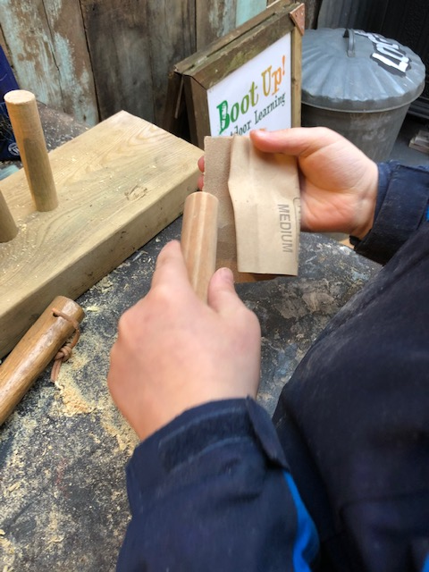

Keeping Safe
_________________________________________________________________

We want to keep to continue supporting you at this very challenging time

We know this is a very difficult time for everyone and you may feel worried about yourself, your family and your friends.

We want to be here for you, to help you to talk about how you are feeling and to listen to you without judgement.

We want to make sure everyone understands why we need to make some changes and your dedicated staff member will explain them is such a way you will understand.

Any questions? Call Jane on 07967132919 or email jane@bootup.org.uk

Keeping Safe
------------------------------------------------------------------------------------------------
Safety

To keep you and your family and our staff team safe we have introduced some changes to our normal way of working

We are checking EVERYONE’S temperature on arrival – YES ! that is staff, young people and visitors

We are asking EVERYONE to wash their hands when they arrive and throughout the day

We will be using disposable paper towels

Everyone has HAND SANITSER, staff carry it and there are sanitiser stations across the site and we will use it regularly

We will help EVERYONE to remember that we need to keep 2m apart from each other; We do this gently and help everyone to understand why

Keeping Safe
------------------------------------------------------------------------------------------------
Changes

Changes you will see

Bubbles
You will be asked to work one to one as usual but within your ‘bubble’, swapping between two staff at the change of sessions.

Masks
If you haven’t got your own, we have disposable face masks. If necessary, we will ask staff and young people to wear them at certain times when close face-to-face contact is unavoidable – to keep you safe

Lunch
It is a shame but we will not be able to all sit together at lunchtime

You will have to bring you own PACKED LUNCH and drinks bottle and eat it with your member of staff in different locations

We will have disposable cups for break time

Toilet Breaks
You will need to ask to use the toilet and you will be accompanied by a member of staff who will ask you to use wipes to clean after use

There will be a hand wash station with paper towels and sanitiser at the toilets

Keeping Safe
------------------------------------------------------------------------------------------------

Activities
We won’t be able to offer some activities such as :-

Cooking

Team games such as Frisbee or Football

Circle Time/ Fie Pit at the end of the day

These activities can only be done safely with close contact and we know we need to avoid this.

There are LOTS of other things we can do though!

